**Materials Data Curation System:**

**Setup instructions for Mac Os**

Please follow these instructions to setup the MDCS on Mac. This will deploy a test server that you will be able to use to test the different MDCS features. The automatic installer is not meant to deploy production systems.

The last steps contain crucial instructions on database initialization and migration.

1. **BACKUP YOUR DATA: Please make a copy of the previous MDCS Application.**
2. **Make sure to stop all MDCS instances.**
3. Double-click on the automatic installer.

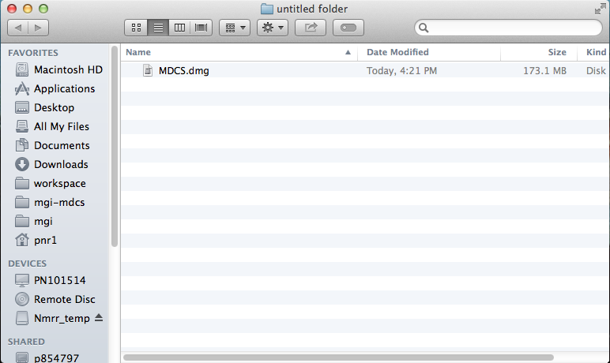

1. A pop-up will appear. **Please drag the Folder to the Applications Folder**

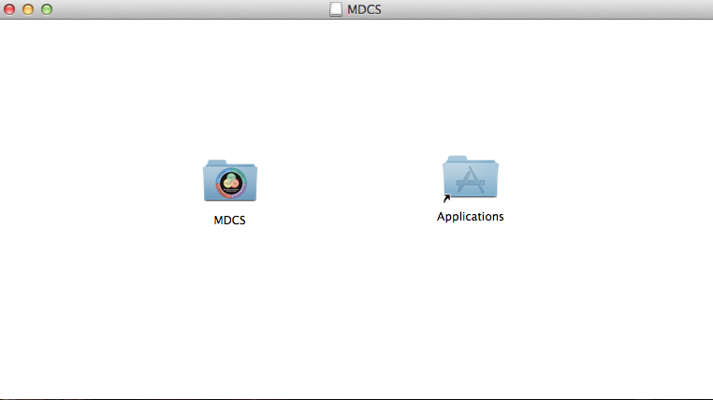

1. **The program is now well installed on your MAC** and you can access it by going under /Applications/MDCS/MDCS.app.

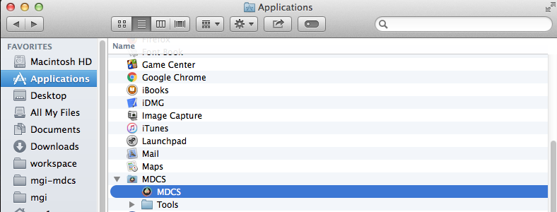

**If you need to migrate data from another version, please follow the following instructions.**

1. Go under /Applications/MDCS/Tools
2. Click on ‘Retrieve previous data’.

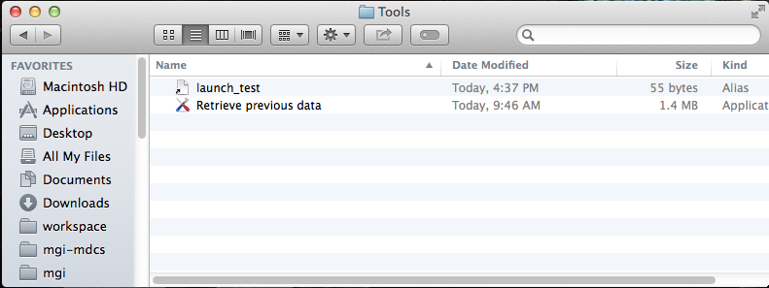

1. Follow the program instructions. You will have to select the previous Mac Application from which you want to retrieve the data and select the new version just installed:

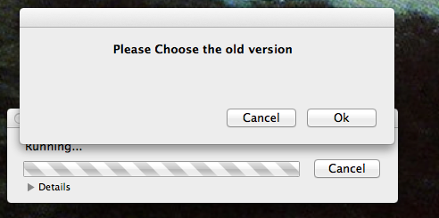

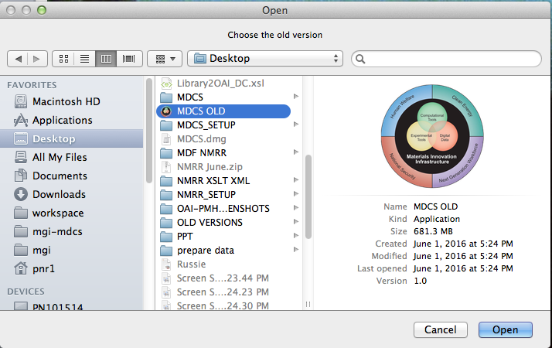

1. Click on Open

5) Select the new version under /Applications/MDCS/MDCS.app

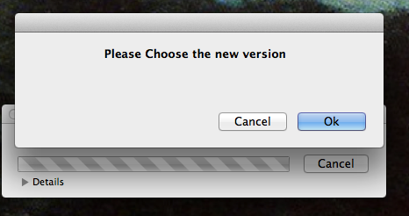

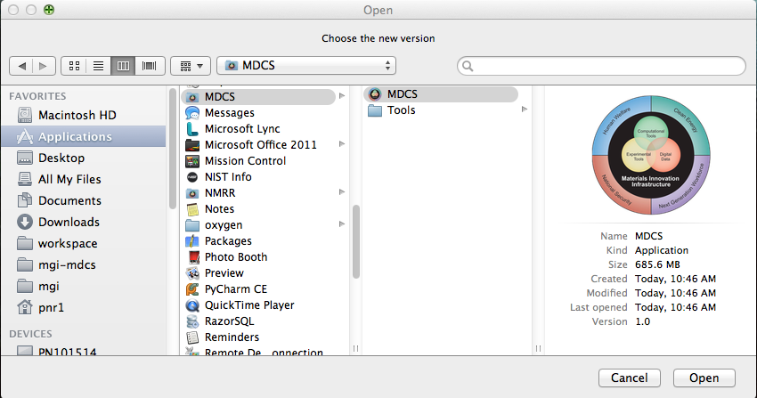

1. Click on open

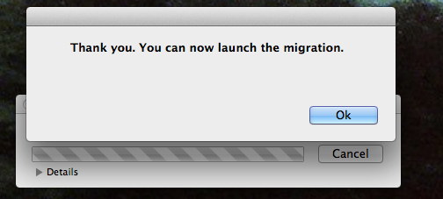

1. Now, you can launch the ‘Launch_migration’ script under /Applications/MDCS/Tools. Please read all the instructions carefully. Because you are installing the application on MAC, you just have to make a backup of the data by making a copy of your previous MDCS.
2. Now that the system has been installed and setup, you can access it by going under Application/MDCS/MDCS.app.